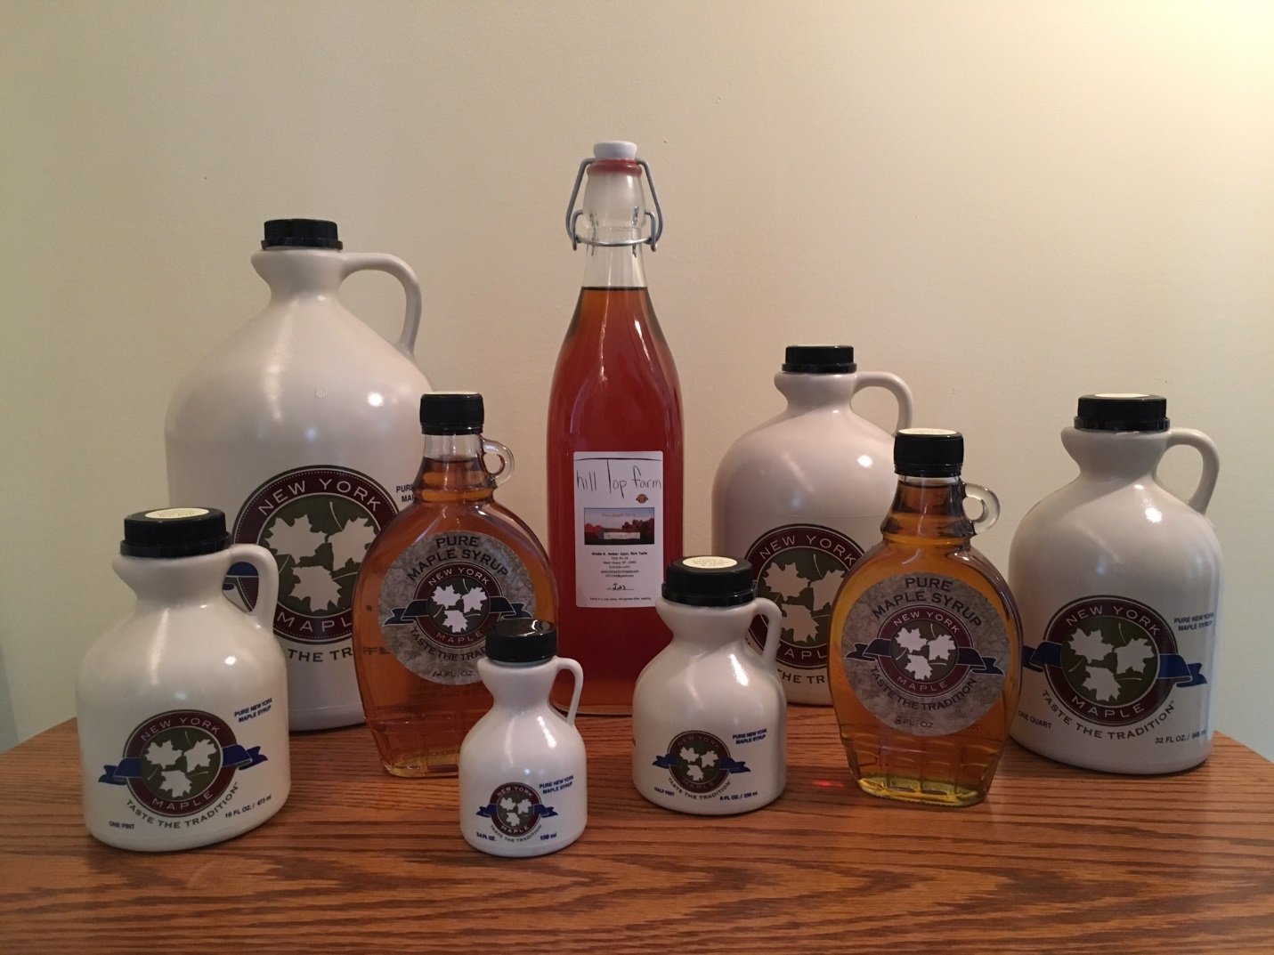

Farm Fresh, Farm Priced. Shipping available.